
2022-2023-3 Advanced Machine Learning in Intelligent Engineering Systems
Final Report

Title：Application of machine learning in game field
Name：RuiJie MA
Stu. No.: 2105030214
Specialization：Intelligent Perception Engineering
Class：21-02

2023年 7月 31 日
Application of machine learning in game field

Abstract: Games are widely recognized as the ninth art form and have experienced a resurgence with the popularity of the meta-universe concept. The level of intelligence exhibited by non-player characters (NPCs) in games is continuously improving, thanks to advancements made by OpenAL and DeepMind. It is conceivable that the immersive scenarios depicted in movies like "Ready Player One" will soon become a reality. Furthermore, in today's society, where individuals often seek deep engagement, there exists a significant market for human-like AI characters in games, particularly in the realm of GalGames. Consequently, machine learning is poised to revolutionize the gaming industry. This article provides an overview of the applications of machine learning in gaming.
Key words: machine learning, gaming, emotional recognition, self-organizing behavior, group intelligence
1.Overview of machine learning
Machine learning encompasses various definitions within the academic community. Essentially, it is a tool employed to solve problems and enhance computer intelligence, much like how mathematical models are utilized for problem-solving. Engineers feed data into computers, which employ mathematical methods to uncover underlying patterns in the data. These patterns are then utilized to construct models that can predict new patterns and effectively address problems.
Over the years, significant progress has been made in the field of machine learning. Traditional techniques involved the use of neural networks, random forests, decision trees, and the like. As the field has evolved, prominent algorithms such as generative adversarial networks and deep reinforcement learning have emerged, playing a vital role in the gaming industry.

2. Machine Learning for Self-Organizing Behavior and Group Intelligence in Games
Self-organizing behavior refers to the spontaneous decision-making exhibited by NPCs in games. These decisions are influenced by the virtual environment in which the NPCs reside and their corresponding needs, leading NPCs with different characteristics to make distinct decisions. On the other hand, group intelligence pertains to the interaction and socialization between NPCs within the game. In games like The Sims 4, a comprehensive environmental chain has been developed, where characters react to hunger, fatigue, and other factors, resulting in emotional responses that influence their actions. The game also emphasizes social aspects, allowing players to control their characters and foster relationships with other characters. NPCs can interact with each other independently and develop various relationships based on their character traits and dialogue, such as friends, intimates, lovers, or even family members. NPCs possess unique personalities and talents, which influence their choices in education or careers. While not all developers utilize machine learning algorithms, it is foreseeable that many of these algorithms can contribute to more complex and intelligent self-organizing behavior and group intelligence in games. Examples include genetic algorithms that enable characters to reproduce offspring with distinct genes and traits, and reinforcement learning algorithms that facilitate decision-making behaviors and expressions described above.
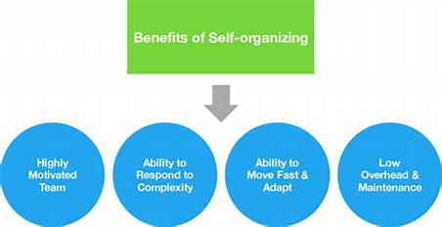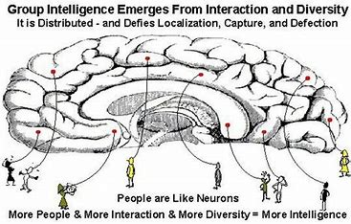

3. Application of Machine Learning to Procedural City Generation in Games
Procedural city generation is a technique that employs algorithms and rules to create virtual cities that exhibit realism and diversity. This approach saves considerable time compared to manual modeling and design, enabling the construction of unique cities according to desired styles. In the context of procedural city generation, generative adversarial networks (GANs) can be utilized. GANs consist of two structures: a generator and a discriminator. Both structures are based on neural network models. The generator abstracts the problem at hand into a mathematical representation and produces feasible solutions after model analysis. The discriminator, on the other hand, evaluates the generated solutions from the generator, determining their feasibility and compliance with requirements. Assuming N iterations, the generator produces a feasible solution in each iteration, which is then evaluated by the discriminator. If the solution does not meet the criteria, it is iteratively refined until a solution approved by the discriminator is obtained. This iterative process enhances the capabilities of both the generator and the discriminator, resulting in improved models over time. In procedural city generation, a random noise vector is provided as input to the generator, which outputs the data structure of city elements by learning from it. The discriminator's role is to assess the probability that the virtual city data generated by the generator resembles real city data. The generator adjusts its generation rules based on the discriminator's feedback, enabling the production of virtual city data that more closely aligns with the discriminator's evaluation. Through several iterations, a realistic virtual city can be generated. Although commercial games may not have fully implemented generative adversarial networks, numerous researchers, including Pascal Müller and Daniel Aliaga, are exploring the use of GANs to create realistic virtual cities. It is foreseeable that GANs will be widely applied in games in the near future.
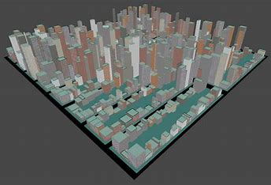
4. Machine Learning in Games for Emotion and Mood Recognition
In contemporary society, there is a growing trend of declining marriage rates and shifting lifestyles, with many individuals finding emotional fulfillment in virtual fiction, films, games, and scripted characters.The following graph depicts the marriage rate line chart for the United States, Singapore, South Korea, Japan, Australia, the United Kingdom, Canada, France, and Italy from 1960 (1920 for the United States) to 2018.
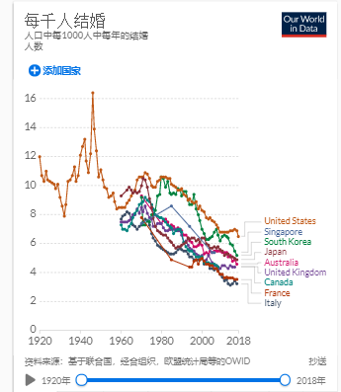
Consequently, the emotional value that game characters can provide to players becomes a significant factor in their game choices. Machine learning holds great potential for emotion and mood recognition in games. While AI struggles to learn and generate genuine human emotions, it can provide reasonable feedback by recognizing and analyzing human emotions. Emotion recognition is a dynamic process that targets an individual's emotional state, but each person may exhibit different behaviors and reactions to the same emotion, which influences human actions significantly. In games, AI can make decisions and interact with players' emotions, providing a more personalized experience. The reactions and behaviors of players generate valuable data that can be used to train machine learning models to express emotions in a vivid and realistic manner. The current approaches to emotion recognition analysis include:
A) Voice Emotion Recognition: Game interactions can incorporate voice recognition algorithms to analyze players' vocal emotions. The tone, speech speed, and emotional content of players' voices can be analyzed to infer their current emotional states. The game can then adjust sound effects, difficulty levels, and plot developments based on these emotional states, allowing NPCs to express appropriate emotions.
B) Facial Expression Recognition: Using camera-enabled sensors, algorithms can analyze players' facial expressions, including eye expressions, mouth shape, and other cues, to infer their current emotional states. The game can generate personalized interactions based on these emotions.
C) Biometric Recognition: This involves utilizing unique biometric sensing technologies, such as measuring adrenaline and dopamine levels or monitoring heart rate changes, to infer players' current moods and provide sensible feedback.
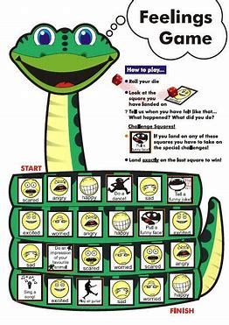
In recent years, there has been extensive research in the field of emotion recognition. Current mainstream research directions include multimodal emotion recognition, contextual modeling, and long-term emotion modeling.
4.1 Multimodal Emotion Recognition
Human emotions often comprise a combination of emotions rather than a single emotion in response to current situations and events. Therefore, relying on a single modality alone may not capture the full range of emotional changes expressed by humans. Multimodal emotion recognition combines multiple modalities to analyze emotional states comprehensively. This technology is currently referenced by well-known systems such as Microsoft Ice and Kenji Machine Monk. Future trends in multimodal emotion recognition include cross-modal learning, combining reinforcement learning and emotion recognition, cross-linguistic and cross-cultural emotion recognition, among others.
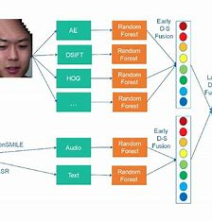
4.2 Contextual Modeling
Contextual modeling involves the process of understanding and reasoning about information within the context of text or conversation and identifying potential correlations. Context modeling includes techniques such as dialogue history modeling, event context modeling, social relationship modeling, and sentiment propagation modeling. Contextual modeling plays a vital role in emotion recognition as human emotional expressions are often influenced by contextual factors. By leveraging chat history, event context, and social relationships, contextual modeling enriches information and better handles ambiguous, implicit, or vague information in language. This approach allows for a more holistic understanding of the entire text. Contextual modeling, mainly employing recurrent neural networks (RNN) and attention mechanism models, has made significant progress in this area.
While these technologies are still relatively new and immature, the current writing and character design in GalGames (games with romantic elements) still rely on human intervention. However, as the technology matures, more emotion recognition technologies will be employed in GalGames, making the AI in games more anthropomorphic and personal. As technology becomes more accessible to the public, the future is likely to witness increased independent game development by individuals.
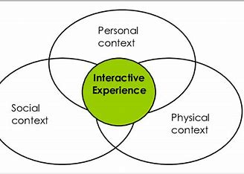
5. Summary
The gaming industry boasts a vast commercial market, surpassing the combined revenue of the movie and music industries by the end of 2018. While machine learning has gained significant traction in fields such as medicine, agriculture, and industry, its integration into the gaming sector is still in its infancy compared to the extensive discussions surrounding Chat GPT. Currently, the gaming industry presents a blue ocean opportunity for machine learning applications, with numerous technical challenges yet to be resolved. Nevertheless, it is foreseeable that the gaming sector will enter a new era with the advent of machine learning.
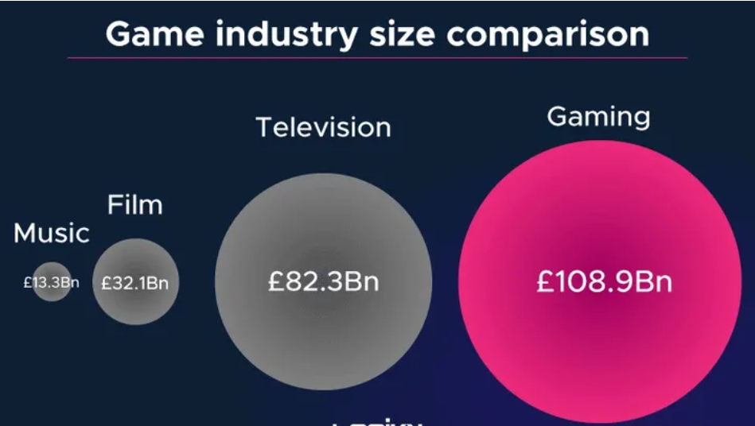

Reference
- Goodfellow, Ian J., Pouget-Abadie, Jean, Mirza, Mehdi, Xu, Bing, Walde-Farley, David, Ozair, Sherjil, Courville, Aaron C., and Bengio, Yoshua. Generative adversarial nets. nIPS, 2014.
- Science - Behavior Science; Findings from Valdosta State University Update Understanding of Behavior Science (Culturo-behavioral Hypercycles and the Metacontingency: Incorporating Self-Organizing Dynamics into an Expanded Model of Cultural Change)[J]. Science Letter,2020.
- J. C P,K. M S,H. C H, et al. Group Intelligence: An Active Learning Exploration of Diversity in Evolution[J]. Journal of Chemical Education,2017,94(6).
- Kim J,Kavak H,Crooks A. Procedural city generation beyond game development[J]. SIGSPATIAL Special,2018,10(2).
- HANDAYANI D,WAHAB A,YAACOB H. EMOTION AND MOOD RECOGNITION IN RESPONSE TO VIDEO[J]. Journal of mobile multimedia,2015,11(3/4).
- And C W C M. Retracted: Multimodal Emotion Recognition Algorithm for Artificial Intelligence Information System[J]. Wireless Communications and Mobile Computing,2023,2023.
- Zheng C,E H,Song M, et al. CMPTF: Contextual Modeling Probabilistic Tensor Factorization for recommender systems[J]. Neurocomputing,2016,205.

